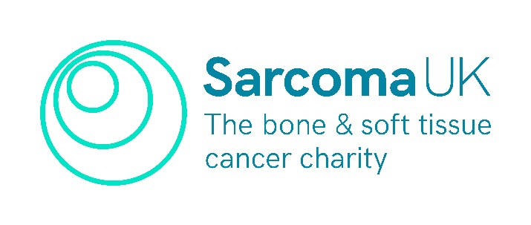

**Sarcoma UK 2024/25 Research Workshop Scheme**

**Application Form**

Please read the Guidance for Applicants before submitting the proposal information in the application below:

**Lead applicant name:**

**Institution / Organisation:**

**Proposed title of meeting / workshop:**

**Planned date of meeting / workshop:**

**Aim of meeting / workshop:**

**Proposed content:**

**Proposed number of attendees:**

**Do you plan to use an external facilitator?**

**Is this a new research group or collaboration?**

**Indicate why the Sarcoma UK Research Workshop Scheme in particular will help facilitate your research:**

**What are the next steps for after the workshop and what is the pathway to future research?**

**Have you secured or applied for any other full or partial funding to support this meeting / workshop?**

**Is this meeting / workshop part of another meeting / conference / event? Y/N**

**If yes, please give the date and location, as well as confirmation from the event organiser that they will accommodate this additional session:**

**Would you like a member of the Sarcoma UK research team to attend your meeting and is there anything specific you would like our support with?**

*If awarded, further details of Sarcoma UK’s role will be discussed and level of support agreed.*

**Would like Sarcoma UK to support or assist this event in any other way, e.g. circulate to researchers or our patient network etc.**

*If support is required, the grant holder must reach out to Sarcoma UK with at least 3 months prior notice to arrange support.*

**Finance Request**

|  |  |
| --- | --- |
| Summary of requested support | Amount |
| 1. Venue Hire | £ |
| 1. Catering Costs | £ |
| 1. Travel & Accommodation Costs | £ |
| 1. Hire of External Facilitator | £ |
| 1. Materials | £ |
| 1. Childcare Provisions | £ |
| 1. Other | £ |
| TOTAL | £ |

**Other:** Please indicate what other (if any) specific financial requests you require and these will be considered on a case by case basis.

**Signature:**

**Date:**

**Application Submission**

Applications must be submitted by Friday 17th January 2025. Please send one document to [research@sarcoma.org.uk](mailto:research@sarcoma.org.uk)

You will be formally notified of the outcome and successful applicants will be sent an agreement to sign.