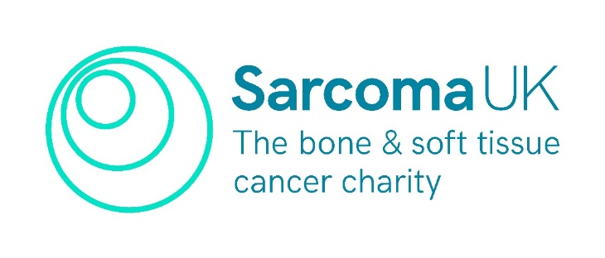
Equal Opportunities Monitoring Form
Confidential

Sarcoma UK is committed to promoting equality and eliminating unlawful discrimination, and we are aiming to achieve diversity in the range of people we recruit. You do not have to answer these questions, and we understand that some of this information is personal and sensitive in nature. However, gathering this data helps us to know if we are succeeding in involving different groups of people, and to change our approach if some groups are not represented.

The information you provide will be processed for monitoring purposes only to assess the effectiveness of our equal opportunities and diversity efforts. All information will be treated in confidence and will not be seen by staff directly involved in the appointment. The questionnaire will be detached from your application, stored separately and will in no way affect your application. To find out how we store, use and manage your data, please visit our website to read our privacy policy at sarcoma.org.uk/privacy-policy.

If you would like this information in an alternative format, or would like help in completing the form, please contact us jobs@sarcoma.org.uk or 0207 856 0445.

Please highlight your answers in bold.

Ethnic origin

These categories are based on the census 2021 categories and recommended by the Commission for Racial Equality.

White | - English, Welsh, Scottish, Northern Irish or British  - Irish  - Gypsy or Irish Traveller  - Other white background (please specify):
Mixed or Multiple ethnic groups | - White and Black Caribbean  - White and Black African  - White and Asian  - Other mixed or multiple ethnic background (please specify):
Black, Black British, African or Caribbean | - African  - Caribbean  - Other Black, African, Caribbean or Black British background (please specify):
Asian or Asian British | - Indian/Pakistani  - Bangladeshi  - Chinese  - Other Asian background (please specify):
Other ethnic group | - Arab  - Other ethnic group (please specify):
Prefer not to say.

Religion or belief

- None  - Atheist  - Jewish  - Buddhist  - Christian | - Muslim  - Sikh  - Hindu  - Other (please specify):  - Prefer not to say

What age group do you belong to?

- 18 - 25  - 26 - 35  - 36 - 45  - 46 - 55 | - 56 - 65  - 65 +  - Prefer not to say

Gender

- Male  - Female | - Prefer not to say  - Prefer to self-identify, please write in:

Gender identity

Is your gender identity the same as that assumed at birth?

- No  Enter gender identity: | - Yes  - Prefer not to say

Sexual orientation

- Bisexual  - Gay man  - Gay woman / lesbian | - Heterosexual  - Prefer to self-identify  - Prefer not to say

Marital status

- Single  - Widowed  - Married / Civil Partnership | - Separated  - Divorced  - Prefer not to say

Disability

The Equality Act 2010 defines disability as a physical or mental impairment which has a substantial and long-term adverse effect on someone’s ability to carry out normal day-to-day activities.

Do you consider yourself to be disabled?

- Yes | - No
If yes what is the nature of the disability?

Declaration

I hereby give my consent to Sarcoma UK processing the data supplied in this form for the purpose of equal opportunities monitoring through recruitment and selection. I acknowledge that my application will be treated the same whether or not I complete this form. I understand that I may withdraw my consent to the processing of this data at any time by notifying jobs@sarcoma.org.uk.

Name

Signature

Date

