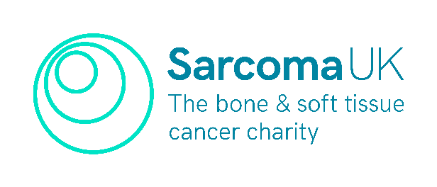
The Tricia Moate Award

Sarcoma UK is offering allied health professionals (AHP) and nurses involved in the care of sarcoma patients, sponsorship to go to the British Sarcoma Group (BSG) annual conference in 2027. For your chance to attend, please fill in this application form, and return to hcp@sarcoma.org.uk by 1 June 2026.

You can apply as an individual or as a team. If your team wins, the different parts of the award can be split amongst your team. More info at sarcoma.org.uk/TMA
The winning application will receive:
- Sponsorship to have access to the BSG conference, including travel, accommodation, conference dinner and access to the full BSG programme.
- Support to attend a further study day that will support personal development and patient care.
- Support from the charity in writing an abstract, formatting and producing a poster for the 2027 BSG Conference.
- Support to visit another Sarcoma Specialist Centre in the UK with overnight accommodation and travel.

Name:
Work Address:
Job title:
Time in role:
Describe your current role in a couple of sentences:

Which Sarcoma Specialist Centre would you prefer to attend?

What study day would you like to attend?

Please explain here in fewer than 500 words how the Tricia Moate Award will contribute to your personal and professional development or the impact this will have for sarcoma patients.

Please send completed applications to hcp@sarcoma.org.uk by 5pm, 1 June 2026. Successful applicants will be notified by 1 July 2026. Good luck!

