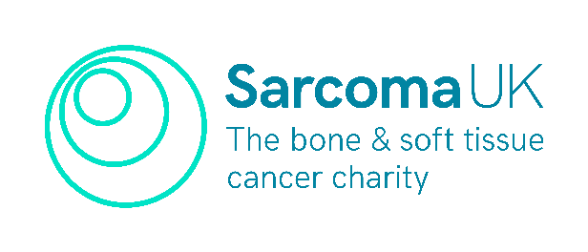
The Tricia Moate Award

Sarcoma UK is offering allied health professionals (AHP) and nurses involved in the care of sarcoma patients, sponsorship to go to the British Sarcoma Group (BSG) annual conference in 2023. For your chance to attend, please fill in this application form, and return to sam.hackett@sarcoma.org.uk by 1 May 2024.

Name:
Work Address:
Job title:
Time in role:
Describe your current role:

Do you have any travel requirements to attend the British Sarcoma Group Conference, chosen study day and visit to sarcoma service?

Which sarcoma service would you prefer to attend?

Give us some details on the chosen sarcoma day:

Please explain here in fewer than 500 words how the Tricia Moate Award will contribute to your personal and professional development or the impact this will have for sarcoma patients.
￼

Please send completed applications to sam.hackett@sarcoma.org.uk by 5pm, 1 May 2022. Successful applicants will be notified on 25 June 2024. Good luck!

